http://www.programiz.com/algorithm/bubble-sort

Bubble Sort Algorithm in Programming
Bubble sort algorithm starts by comparing the first two elements of an array and swapping if necessary, i.e., if you want to sort the elements of array in ascending order and if the first element is greater than second then, you need to swap the elements but, if the first element is smaller than second, you mustn't swap the element. Then, again second and third elements are compared and swapped if it is necessary and this process go on until last and second last element is compared and swapped. This completes the first step of bubble sort.
If there are n elements to be sorted then, the process mentioned above should be repeated n-1 times to get required result. But, for better performance, in second step, last and second last elements are not compared becuase, the proper element is automatically placed at last after first step. Similarly, in third step, last and second last and second last and third last elements are not compared and so on.
A figure is worth a thousand words so, acknowledge this figure for better understanding of bubble sort.
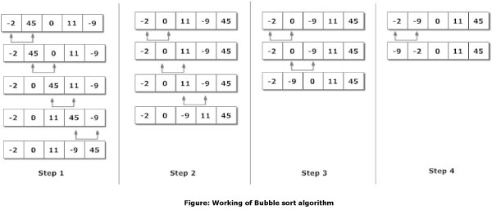
Here, there are 5 elements to the sorted. So, there are 4 steps.

Program To Sort Elements using Bubble Sort Algorithm

/*C Program To Sort data in ascending order using bubble sort.*/
#include <stdio.h>
int main()
{
int data[100],i,n,step,temp;
printf("Enter the number of elements to be sorted: ");
scanf("%d",&n);
for(i=0;i<n;++i)
{
printf("%d. Enter element: ",i+1);
scanf("%d",&data[i]);
}

for(step=0;step<n-1;++step)
for(i=0;i<n-step-1;++i)
{
if(data[i]>data[i+1]) /* To sort in descending order, change > to < in this line. */
{
temp=data[i];
data[i]=data[i+1];
data[i+1]=temp;
}
}
printf("In ascending order: ");
for(i=0;i<n;++i)
printf("%d ",data[i]);
return 0;
}

Enter the number of elements to be sorted: 6
1. Enter element: 12
2. Enter element: 3
3. Enter element: 0
4. Enter element: -3
5. Enter element: 1
6. Enter element: -9
In ascending order: -9 -3 0 1 3 13
Note: Though this code is in C programming, this technique can be applied in any programming to sort elements of an array.
Though bubble sort algorithm is quite popular, there are many other better algorithm than bubble sort. Specially, bubble sort should not be used to sort large data if performance matters in that program.

http://www.java2novice.com/java-sorting-algorithms/bubble-sort/

Program: Implement bubble sort in java.

Bubble sort, also referred to as sinking sort, is a simple sorting algorithm that works by repeatedly stepping through the list to be sorted, comparing each pair of adjacent items and swapping them if they are in the wrong order. The pass through the list is repeated until no swaps are needed, which indicates that the list is sorted. The algorithm gets its name from the way smaller elements "bubble" to the top of the list. Because it only uses comparisons to operate on elements, it is a comparison sort. Although the algorithm is simple, most of the other sorting algorithms are more efficient for large lists.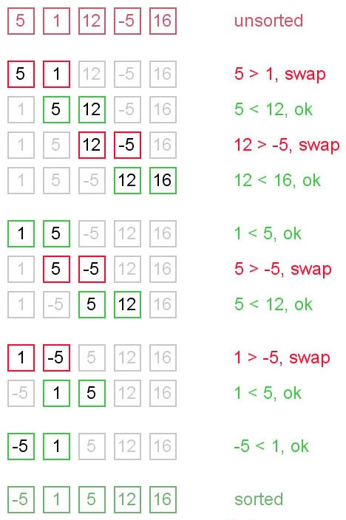
Bubble sort has worst-case and average complexity both О(n2), where n is the number of items being sorted. There exist many sorting algorithms with substantially better worst-case or average complexity of O(n log n). Even other О(n2) sorting algorithms, such as insertion sort, tend to have better performance than bubble sort. Therefore, bubble sort is not a practical sorting algorithm when n is large.Performance of bubble sort over an already-sorted list (best-case) is O(n).

?
1  2  3  4  5  6  7  8  9  10  11  12  13  14  15  16  17  18  19  20  21  22  23  24  25  26  27  28  29  30  31  32  33  34  35  36  37  38  39  40  41 | package com.java2novice.algos;  public class MyBubbleSort {  // logic to sort the elements  public static void bubble_srt(int array[]) {  int n = array.length;  int k;  for (int m = n; m >= 0; m--) {  for (int i = 0; i < n - 1; i++) {  k = i + 1;  if (array[i] > array[k]) {  swapNumbers(i, k, array);  }  }  printNumbers(array);  }  }  private static void swapNumbers(int i, int j, int[] array) {  int temp;  temp = array[i];  array[i] = array[j];  array[j] = temp;  }  private static void printNumbers(int[] input) {  for (int i = 0; i < input.length; i++) {  System.out.print(input[i] + ", ");  }  System.out.println("\n");  }  public static void main(String[] args) {  int[] input = { 4, 2, 9, 6, 23, 12, 34, 0, 1 };  bubble_srt(input);  }  }

Output:
2, 4, 6, 9, 12, 23, 0, 1, 34,

2, 4, 6, 9, 12, 0, 1, 23, 34,

2, 4, 6, 9, 0, 1, 12, 23, 34,

2, 4, 6, 0, 1, 9, 12, 23, 34,

2, 4, 0, 1, 6, 9, 12, 23, 34,

2, 0, 1, 4, 6, 9, 12, 23, 34,

0, 1, 2, 4, 6, 9, 12, 23, 34,

0, 1, 2, 4, 6, 9, 12, 23, 34,

0, 1, 2, 4, 6, 9, 12, 23, 34,

0, 1, 2, 4, 6, 9, 12, 23, 34,

Program: Implement selection sort in java.

The selection sort is a combination of searching and sorting. During each pass, the unsorted element with the smallest (or largest) value is moved to its proper position in the array. The number of times the sort passes through the array is one less than the number of items in the array. In the selection sort, the inner loop finds the next smallest (or largest) value and the outer loop places that value into its proper location.
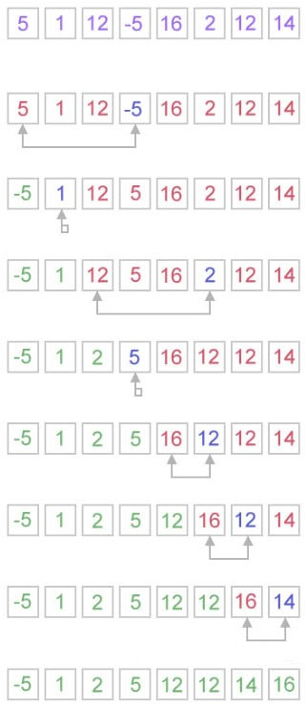
Selection sort is not difficult to analyze compared to other sorting algorithms since none of the loops depend on the data in the array. Selecting the lowest element requires scanning all n elements (this takesn − 1 comparisons) and then swapping it into the first position. Finding the next lowest element requires scanning the remaining n − 1 elements and so on, for (n − 1) + (n − 2) + ... + 2 + 1 = n(n − 1) / 2 ∈ Θ(n2) comparisons. Each of these scans requires one swap for n − 1 elements.

?
1  2  3  4  5  6  7  8  9  10  11  12  13  14  15  16  17  18  19  20  21  22  23  24  25  26  27  28  29  30 | package com.java2novice.algos;  public class MySelectionSort {  public static int[] doSelectionSort(int[] arr){  for (int i = 0; i < arr.length - 1; i++)  {  int index = i;  for (int j = i + 1; j < arr.length; j++)  if (arr[j] < arr[index])  index = j;  int smallerNumber = arr[index];  arr[index] = arr[i];  arr[i] = smallerNumber;  }  return arr;  }  public static void main(String a[]){  int[] arr1 = {10,34,2,56,7,67,88,42};  int[] arr2 = doSelectionSort(arr1);  for(int i:arr2){  System.out.print(i);  System.out.print(", ");  }  }  }

Output:
2, 7, 10, 34, 42, 56, 67, 88,

Program: Implement insertion sort in java.

Insertion sort is a simple sorting algorithm, it builds the final sorted array one item at a time. It is much less efficient on large lists than other sort algorithms.
Advantages of Insertion Sort:
1) It is very simple.
2) It is very efficient for small data sets.
3) It is stable; i.e., it does not change the relative order of elements with equal keys.
4) In-place; i.e., only requires a constant amount O(1) of additional memory space.
Insertion sort iterates through the list by consuming one input element at each repetition, and growing a sorted output list. On a repetition, insertion sort removes one element from the input data, finds the location it belongs within the sorted list, and inserts it there. It repeats until no input elements remain.
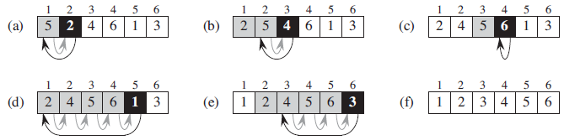
Image source: “Introduction to Algorithms”, The MIT Press

The best case input is an array that is already sorted. In this case insertion sort has a linear running time (i.e., Θ(n)). During each iteration, the first remaining element of the input is only compared with the right-most element of the sorted subsection of the array. The simplest worst case input is an array sorted in reverse order. The set of all worst case inputs consists of all arrays where each element is the smallest or second-smallest of the elements before it. In these cases every iteration of the inner loop will scan and shift the entire sorted subsection of the array before inserting the next element. This gives insertion sort a quadratic running time (i.e., O(n2)). The average case is also quadratic, which makes insertion sort impractical for sorting large arrays. However, insertion sort is one of the fastest algorithms for sorting very small arrays, even faster than quicksort; indeed, good quicksort implementations use insertion sort for arrays smaller than a certain threshold, also when arising as subproblems; the exact threshold must be determined experimentally and depends on the machine, but is commonly around ten.

?
1  2  3  4  5  6  7  8  9  10  11  12  13  14  15  16  17  18  19  20  21  22  23  24  25  26  27  28 | package com.java2novice.algos;  public class MyInsertionSort {  public static void main(String a[]){  int[] arr1 = {10,34,2,56,7,67,88,42};  int[] arr2 = doInsertionSort(arr1);  for(int i:arr2){  System.out.print(i);  System.out.print(", ");  }  }  public static int[] doInsertionSort(int[] input){  int temp;  for (int i = 1; i < input.length; i++) {  for(int j = i ; j > 0 ; j--){  if(input[j] < input[j-1]){  temp = input[j];  input[j] = input[j-1];  input[j-1] = temp;  }  }  }  return input;  }  }

Output:
2, 7, 10, 34, 42, 56, 67, 88,

<< Previous Program | Next Program >>

Program: Implement quick sort in java.

Quicksort or partition-exchange sort, is a fast sorting algorithm, which is using divide and conquer algorithm. Quicksort first divides a large list into two smaller sub-lists: the low elements and the high elements. Quicksort can then recursively sort the sub-lists.
Steps to implement Quick sort:
1) Choose an element, called pivot, from the list. Generally pivot can be the middle index element.
2) Reorder the list so that all elements with values less than the pivot come before the pivot, while all elements with values greater than the pivot come after it (equal values can go either way). After this partitioning, the pivot is in its final position. This is called the partition operation.
3) Recursively apply the above steps to the sub-list of elements with smaller values and separately the sub-list of elements with greater values.
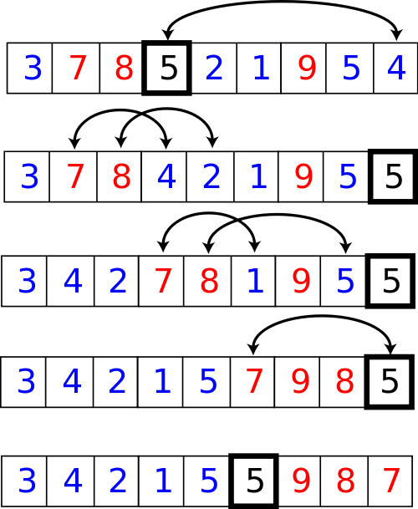

The complexity of quick sort in the average case is Θ(n log(n)) and in the worst case is Θ(n2).

?
1  2  3  4  5  6  7  8  9  10  11  12  13  14  15  16  17  18  19  20  21  22  23  24  25  26  27  28  29  30  31  32  33  34  35  36  37  38  39  40  41  42  43  44  45  46  47  48  49  50  51  52  53  54  55  56  57  58  59  60  61  62  63  64  65  66  67  68 | package com.java2novice.sorting;  public class MyQuickSort {  private int array[];  private int length;  public void sort(int[] inputArr) {  if (inputArr == null || inputArr.length == 0) {  return;  }  this.array = inputArr;  length = inputArr.length;  quickSort(0, length - 1);  }  private void quickSort(int lowerIndex, int higherIndex) {  int i = lowerIndex;  int j = higherIndex;  // calculate pivot number, I am taking pivot as middle index number  int pivot = array[lowerIndex+(higherIndex-lowerIndex)/2];  // Divide into two arrays  while (i <= j) {  /**  * In each iteration, we will identify a number from left side which  * is greater then the pivot value, and also we will identify a number  * from right side which is less then the pivot value. Once the search  * is done, then we exchange both numbers.  */  while (array[i] < pivot) {  i++;  }  while (array[j] > pivot) {  j--;  }  if (i <= j) {  exchangeNumbers(i, j);  //move index to next position on both sides  i++;  j--;  }  }  // call quickSort() method recursively  if (lowerIndex < j)  quickSort(lowerIndex, j);  if (i < higherIndex)  quickSort(i, higherIndex);  }  private void exchangeNumbers(int i, int j) {  int temp = array[i];  array[i] = array[j];  array[j] = temp;  }  public static void main(String a[]){  MyQuickSort sorter = new MyQuickSort();  int[] input = {24,2,45,20,56,75,2,56,99,53,12};  sorter.sort(input);  for(int i:input){  System.out.print(i);  System.out.print(" ");  }  }  }

Output:
2 2 12 20 24 45 53 56 56 75 99

<< Previous Program | Next Program >>

Program: Implement merge sort in java.

Merge sort is a divide and conquer algorithm.
Steps to implement Merge Sort:
1) Divide the unsorted array into n partitions, each partition contains 1 element. Here the one element is considered as sorted.
2) Repeatedly merge partitioned units to produce new sublists until there is only 1 sublist remaining. This will be the sorted list at the end.
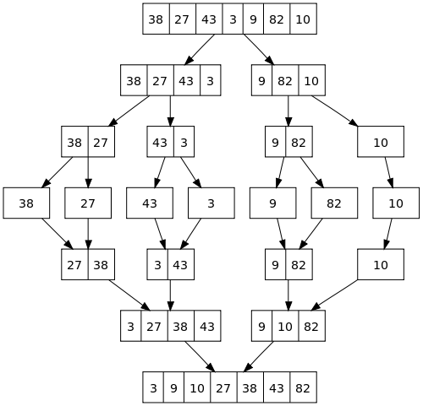

Merge sort is a fast, stable sorting routine with guaranteed O(n*log(n)) efficiency. When sorting arrays, merge sort requires additional scratch space proportional to the size of the input array. Merge sort is relatively simple to code and offers performance typically only slightly below that of quicksort.

?
1  2  3  4  5  6  7  8  9  10  11  12  13  14  15  16  17  18  19  20  21  22  23  24  25  26  27  28  29  30  31  32  33  34  35  36  37  38  39  40  41  42  43  44  45  46  47  48  49  50  51  52  53  54  55  56  57  58  59  60  61  62  63  64  65 | package com.java2novice.sorting;  public class MyMergeSort {  private int[] array;  private int[] tempMergArr;  private int length;  public static void main(String a[]){  int[] inputArr = {45,23,11,89,77,98,4,28,65,43};  MyMergeSort mms = new MyMergeSort();  mms.sort(inputArr);  for(int i:inputArr){  System.out.print(i);  System.out.print(" ");  }  }  public void sort(int inputArr[]) {  this.array = inputArr;  this.length = inputArr.length;  this.tempMergArr = new int[length];  doMergeSort(0, length - 1);  }  private void doMergeSort(int lowerIndex, int higherIndex) {  if (lowerIndex < higherIndex) {  int middle = lowerIndex + (higherIndex - lowerIndex) / 2;  // Below step sorts the left side of the array  doMergeSort(lowerIndex, middle);  // Below step sorts the right side of the array  doMergeSort(middle + 1, higherIndex);  // Now merge both sides  mergeParts(lowerIndex, middle, higherIndex);  }  }  private void mergeParts(int lowerIndex, int middle, int higherIndex) {  for (int i = lowerIndex; i <= higherIndex; i++) {  tempMergArr[i] = array[i];  }  int i = lowerIndex;  int j = middle + 1;  int k = lowerIndex;  while (i <= middle && j <= higherIndex) {  if (tempMergArr[i] <= tempMergArr[j]) {  array[k] = tempMergArr[i];  i++;  } else {  array[k] = tempMergArr[j];  j++;  }  k++;  }  while (i <= middle) {  array[k] = tempMergArr[i];  k++;  i++;  }  }  }

Output:
4 11 23 28 43 45 65 77 89 98

<< Previous Program

